THE McKENZIE INSTITUTE RE-ASSESSMENT FORM

Date

Name

Visit Number

Check of Management Strategies:
Posture Change: Yes / No
Performing Exercises: Yes / No
Frequency: Appropriate / Not appropriate Symptom Response when performing exercises___________________________
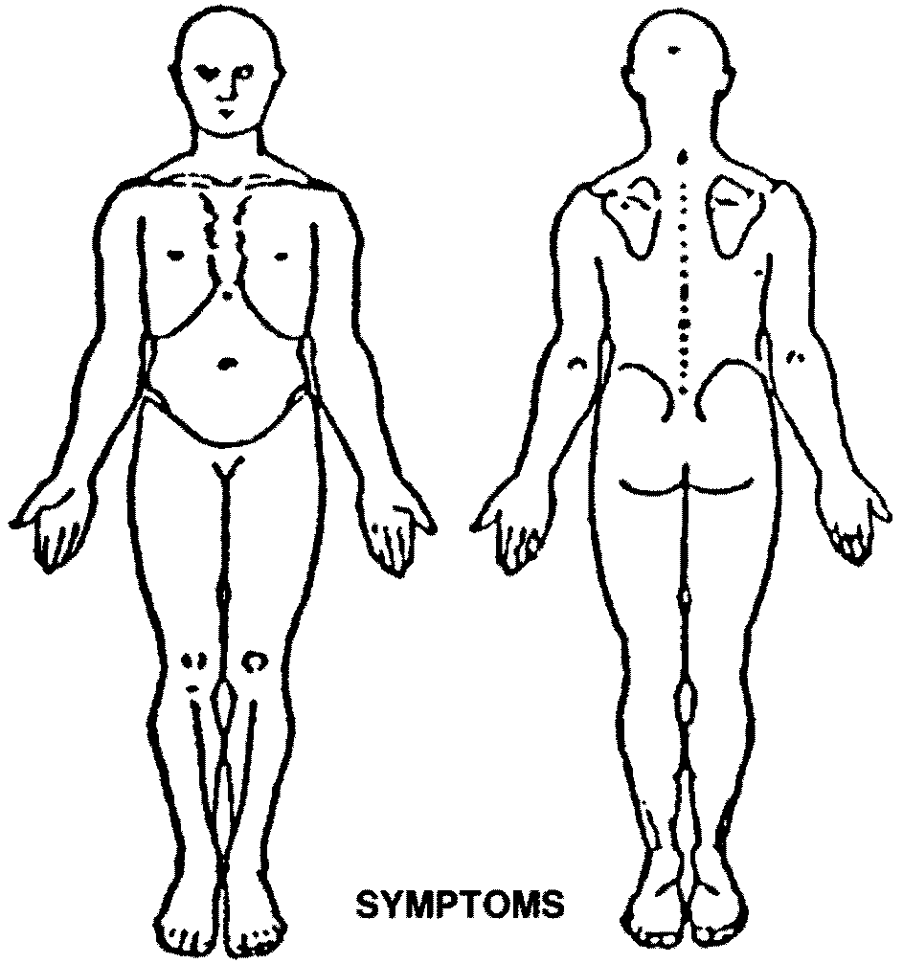
Technique: Good / Needs correcting

Adherence / Commitment Excellent / Good / Fair / Poor
Symptomatic Presentation:

Pain Location: Centralised / Same / Peripheralised ______________________
Frequency: Better / Same / Worse
Severity: 0 ______________________________10
Better / Same / Worse
Functional Status: % improvement since initial assessment:
0 _________________________________ 100%
Functional questionnaire:___________________________________
Mechanical Presentation:
Sitting Posture: Consistent with plan; yes / no Standing Posture: Consistent with plan; yes / no
Deformity: Yes / No / Not applicable Neurological Testing: Better / Same / Worse / Not applicable ________
Movement Loss: Better / Same / Worse __________________________________________________________________
Current Exercise Technique: Good / Needs correcting Symptom Response: __________________________________
Repeated Movements: Better / Same / Worse
SUMMARY: Better / Same / Worse Overall improvement since initial assessment: 0 _______________ 100%

Classification Confirmed: Yes / No
Further Testing (if required): Repeated Movements:_____________________________________________________________
________________________________________________________________________________________________________
Other Testing: ____________________________________________________________________________________________
Revised Classification (if appropriate):
Derangement Dysfunction Postural OTHER (subgroup) _________________________

Management Today:

Education: ______________________________________________________________________________________________

Treatment: ______________________________________________________________________________________________
Plan: ___________________________________________________________________________________________________
Potential Drivers of Pain and / or Disability:___________________________________________________________________

Equipment Provided: Lumbar Roll ___________________________ Cervical Roll______________________________

TYOB/TYON/TYOS/TYOK/TYOH ____________ Night Roll ____________ Signature ______________________________

